Starting MongoDB

1. Download MongoDB
2. When Installing MongoDB, choose Complete version not custom. You can choose custom if you want a smaller/easier naming convention.
3. Go into command prompt and cd into MongoDB
4. Then type **mongod** into the command prompt. An error will appear as follows: 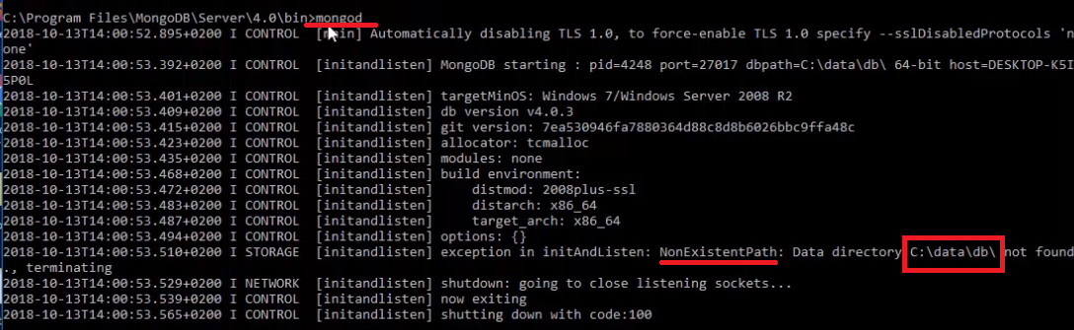
5. When this happens, just create a folder on your local disk (C drive) called data and another folder in data called db.



This is where all the data will be stored.

1. After you created folders, run the **mongod** command again and it should be successful.
2. Open another cmd and use the same path as above and type in **mongo.**

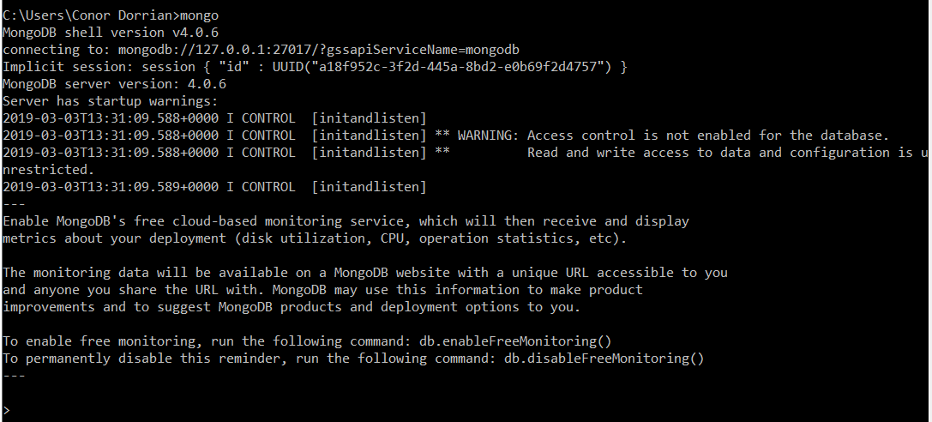

1. This will open the mongo shell. From here you can create a database etc.

Run MongoDB Anywhere

To run **mongod** and **mongo** in any directory, follow the steps provided.

To Run the **mongod** and **mongo** command anywhere instead of always having to go into the folder.

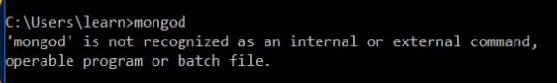

To do this you need to set the environmental variables up. Just type “environmental variables” in the start menu or go to system then advanced settings then environmental variables.

In system variables. Double click “path” and enter a new MongoDB bin path inside path



Then close all terminals and open a new terminal/cmd and type **mongod** to run the server and in a new terminal/cmd type **mongo.** Which will take you straight to mongo shell anywhere in the system.

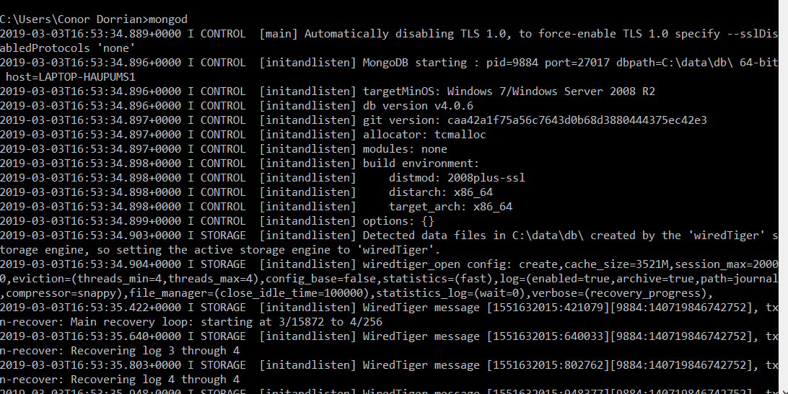

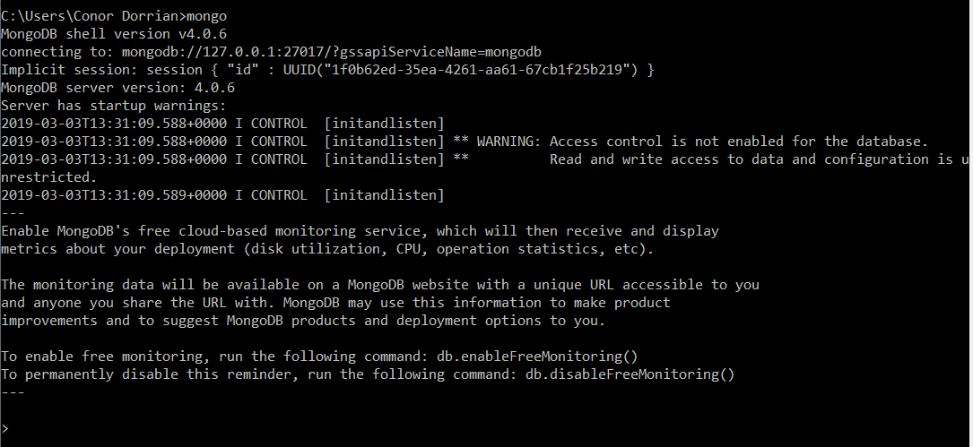

Some Mongo shell commands

show dbs === Shows the database

use firstDatabase === Create a database named firstDatabase

db.books.insert({“name”:” Game of Thrones book”}) === Collection Name Books with book names in the collection

show dbs === Shows the database

show collections === Shows all collections in firstDatabase

db.books.find() === Shows the values in books

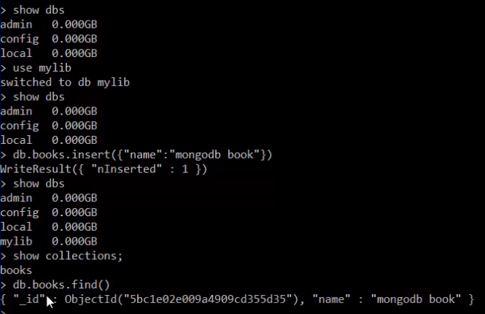

Figure an example of some commands.